
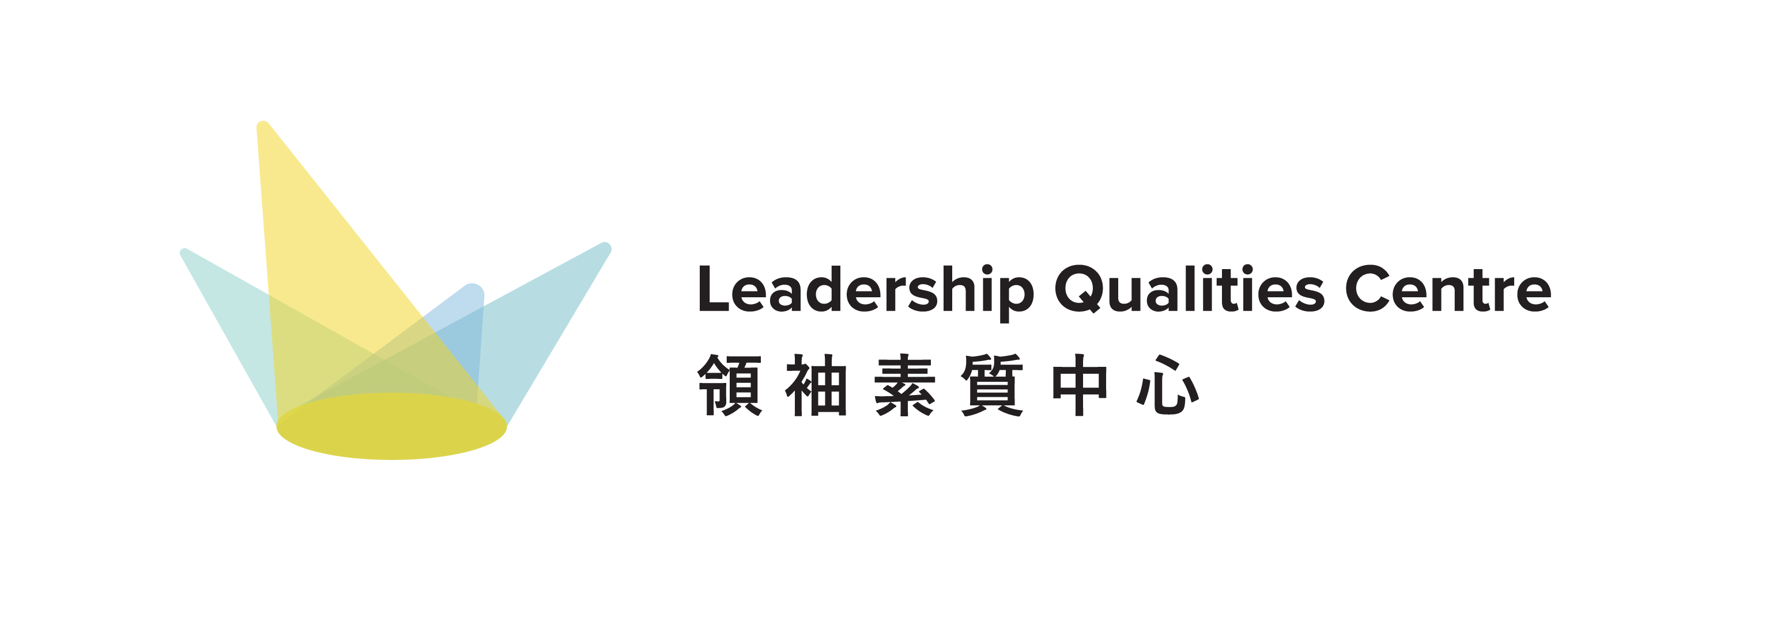


Ten Thousand People's Scheme (TTPS)
Application for Special Allowance

Background of the Ten Thousand People's Scheme (TTPS):

The Ten Thousand People's Scheme (TTPS) provides UGC-funded undergraduate students with diversified experiential learning opportunities in the mainland. Through cultural exchanges, short courses, research projects, internships, academic competitions, service learning activities, and visits, TTPS promotes exchanges between Hong Kong and Mainland tertiary students and enhances their understanding of the nation.

Application details:
Eligibility: | - HKBU UGC-funded UG students who completed the TTPS with a programme end date on or after 1st May 2025  - Students who meet the requirements for the “General Allowance” and have total expenses incurred in the programme that exceed twice the amount of the General Allowance.  - Examples of eligible items in Special Allowance:  - Round-trip transportation  - Accommodation arranged by the host but at students’ own expense (Coverage: Official Travel Period and +1/-1 day)  - Tuition/Course material fee (e.g. Course fee for summer school programmes)  - Fee incurred from other activities, which is necessary for the programme (e.g. ticket fee, transportation fee), but not covered by the host institution  - Examples of non-eligible items:  - Meal  - Fare for self-arranged activities  - Fare of Local transportation  - Additional cost of HKBU insurance  - Other personal expenses
Application documents: | - Application form (with evaluation and reflective journal)  - Proof of programme completion issued by mainland institutions  - Proof of additional cost (e.g. receipt)  - 5 photos taken during your outbound programme (no less than 1MB per photo)
Deadline for application: | - Within one month of completing the outbound programme under TTPS
Payment: | - Students submitting the completed application by 31 October or 30 April will receive an allowance in December or June respectively.  - Students can apply for an allowance that covers a maximum of 50% of expenses incurred for the programme, with a ceiling of HK$5,000.  - Any subsidies granted by other HKBU funding sources for the same programme shall be deducted from the allowance, to avoid double benefits.

Note:
- Students can only receive the allowance once in each academic year.
- Students can only apply for either the General Allowance or Special Allowance for the programme.

Ten Thousand People's Scheme (TTPS)

Application for Special Allowance

Before submission, please read the information carefully on the TTPS website to understand the details of the allowance. Please submit the application form, together with the documentary proof of programme completion, an e-evaluation survey, proof of additional cost, and 5 photos to ttps_sa@hkbu.edu.hk within one month of completing the outbound programme under TTPS.

- Applicant information
Name | (Chinese) | (English)
Student ID |  | Contact No.
E-mail
Study Programme |  | Study Year

- Bank information
Name of the Local Bank |  | Name of Account Holder
Bank Account Code |  | Name of Account Holder

- TTPS information
Name of TTPS |  | Code of TTPS
Duration |  | Destination

- Details of expenses incurred from the programme
Item | Amount (RMB) | Description

- Name and Amount of other HKBU subsidies :
Status: | Intended to apply / Being processed / Being granted / None  * Please delete as appropriate
Name of Subsidy:
Offering Office/ Department:
Amount:

Signature: |  | Date:

Ten Thousand People's Scheme (TTPS) Award

Student Evaluation Survey

Please click the link or scan the QR code below to complete the evaluation survey:
Link:
https://forms.office.com/r/2KP2HfNZce

QR code:


☐I have completed the evaluation survey.
Please send the completed document to ttps_sa@hkbu.edu.hk, together with
- 5 photos taken during your outbound programme (not less than 1MB per photo)
- Documentary proof of programme completion issued by mainland institutions
- Proof of expenses incurred from programme (e.g. receipt)
within one month of outbound programme completion.

